

**Module Code & Module Title**

**CC4002NA Information System**

**Assessment Weightage & Type**

**30% Individual Coursework**

**Year and Semester**

**2019 Spring**

**Student Name: Rabin Dhakal**

**London Met ID: 18030799**

**College ID: NP01CP4S190020**

**Assignment Due Date: August 30, 2019**

**Assignment Submission Date: August 30, 2019**

*I confirm that I understand my coursework needs to be submitted online via Google Classroom under the relevant module page before the deadline in order for my assignment to be accepted and marked. I am*

*fully aware that late submissions will be treated as non-submission and a mark of zero will be awarded.*

Table of Contents

Table of Figure 2

Table of table 4

Introduction 5

Discussion and analysis 6

Home 6

Product Page 9

Blog 11

Research Page 13

Contact Us Page 15

Product Description Page 17

Testing 18

Test 1 18

Test 2 20

Test 3 22

Test 4 26

Test 5 27

Conclusion 29

References 30

# Table of Figure

Figure 1: Wireframe of Home Page 7

Figure 2: Design of Home Page 8

Figure 3: Wireframe of Product page 9

Figure 4: Design of the Product Page 10

Figure 5: Wireframe of Blog Page 11

Figure 6: Design of the blog page 12

Figure 7: Wireframe of the Research page 13

Figure 8:Design of the Research Page 14

Figure 9: Wireframe of Contact us page 15

Figure 10: Design of Contact Us Page 16

Figure 11:Design of Product Description Page 17

Figure 12: Black Box testing (softwaretestingfundamentals, 2015) 18

Figure 13: Before the courser was hovered 19

Figure 14: After the courser is hovered 19

Figure 15: Image Slider Test 1 20

Figure 16: Image Slider Test 2 20

Figure 17: Image Slider Test 3 21

Figure 18: Form Validation Test When all field are empty 22

Figure 19: Form Validation Test When message field is empty 23

Figure 20: Form Validation Test When name field is empty 24

Figure 21: Form validation when all the field are entered 25

Figure 22: Testing Date and Time 26

Figure 23: Testing link Social Media 27

Figure 24: Loaded Instagram on another page 28

# Table of table

Table 1: Hoover test 18

Table 2: Image Slider test 20

Table 3: Form Validation Test When all field are empty 22

Table 4: Form Validation Test When message field is empty 23

Table 5: Form Validation Test When name field is empty 24

Table 6: Form validation when all the field are entered 25

Table 7: Testing Date and Time 26

Table 8: Testing links 27

# Introduction

This individual coursework is about creating an ecommerce website with at least 5 web pages including product, blog, research and contact us page which should be functional good looking and responsive to some extent. This website can directly increase the sales and promotion of the products.

Creating 5 pages of website was not that easy. Detailed researcher was done prior starting the designing and development phase. While doing the coursework the main aim was to complete the coursework on the due date and objective was to create a beautiful and responsive website. The process of development was very much difficult because we were totally new to CSS and JavaScript. Tutors and lecturers helped a lot to complete this coursework.

HTML5, CSS and JavaScript were used to build this website, HTML is the markup language devised to allow website creation. Hyper Text is the method by which user can surf the web. Text, images and other visual content are displayed on the browsers. (Shannon, 2018)

Cascading style sheets referred as CSS is a simple designing language intended to simplify the process of making web pages presentable. CSS describes how the HTML content should look like on the screen when users’ browse the website. (W3Schools, 2016)

Java Scripts can be called as the programming language for the web. Java script is used in the web to change and update both HTML and CSS. Java Script can calculate, manipulated and validate data. JS is client-side script to interact with the user and make dynamic pages. These days there are many libraries and frameworks which has made JavaScript even more popular. JS are used these days in servers and AI as well. (TutotialsPoint, 2014)

Detailed research were done from many website to achieve the main objective of the coursework which was to finish it on time.

# Discussion and analysis

This website was created using simple HTML, CSS and JavaScript. Visual Studio Code was used for the writing codes and Balsamic was used to draw the wireframes. Wireframe is a way to design a website service at the structural level. A wireframe is commonly used to layout content and functionality on a page. Wireframes displays the architecture of the website before the development process. (HAAS, 2011)

Taking the reference of the wireframes which was created earlier all the website were developed.

## Home

Home page consist of the navigation bar and image behind the navigation bar with the special discount message to attract the customers. Below that there is newsletter section in which the users can get monthly email of special recipes. Below that table to display the text and the image slider was created. Image slider was created to show the images of the cakes. And footer section has the button navigation bar and the copyright section below that shows the today’s date and time.

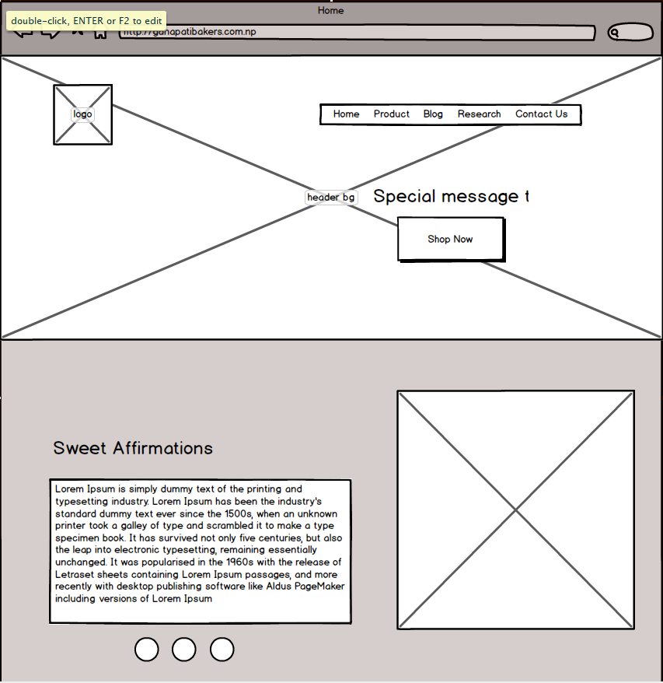

Figure : Wireframe of Home Page

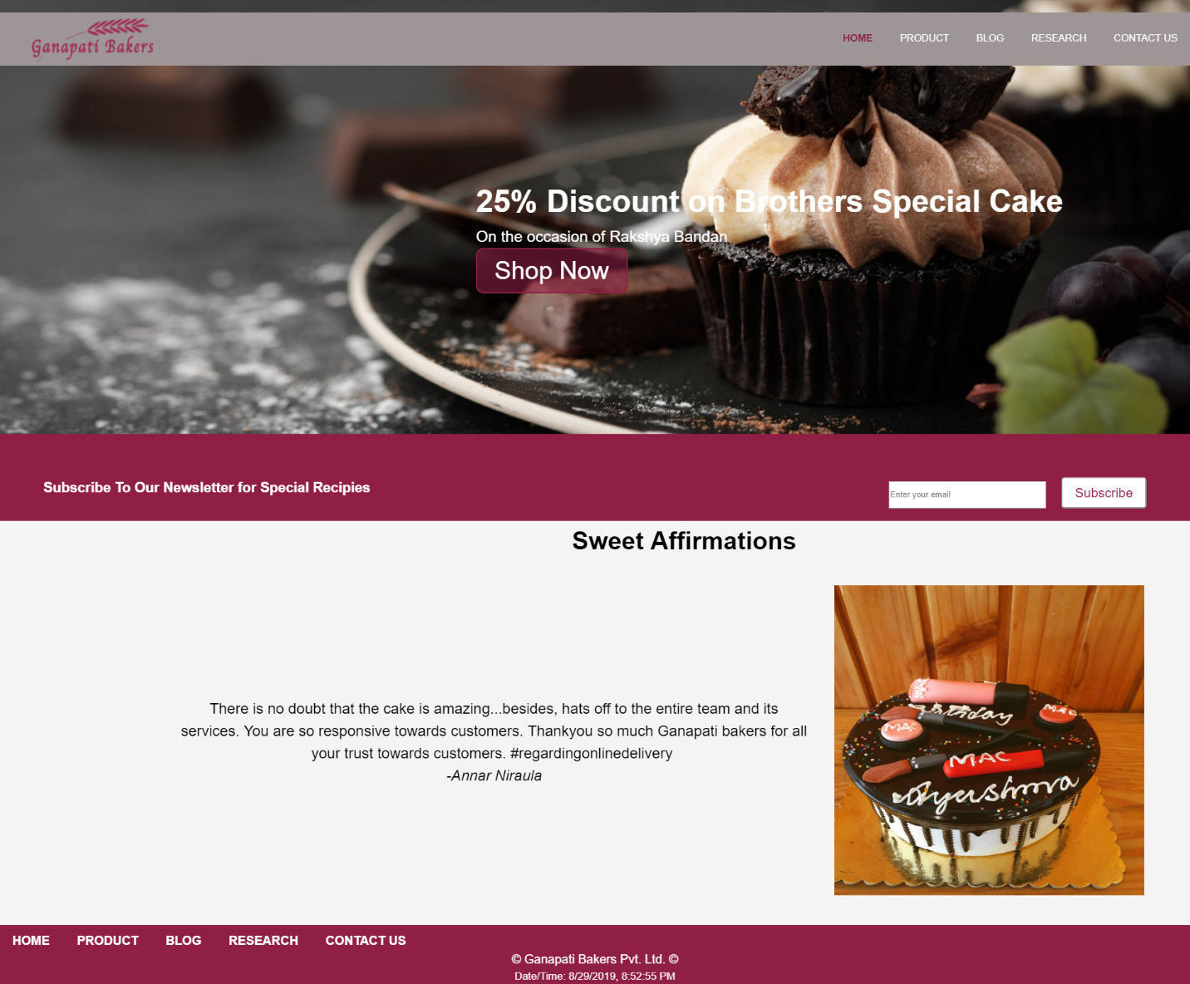

Figure : Design of Home Page

## Product Page

Product page was designed in such a way that customers visiting the website can see the picture of the products and can navigate to the details page of the product and the header message has the button through which the user are navigated to contact page if they have difficulty in choosing products.

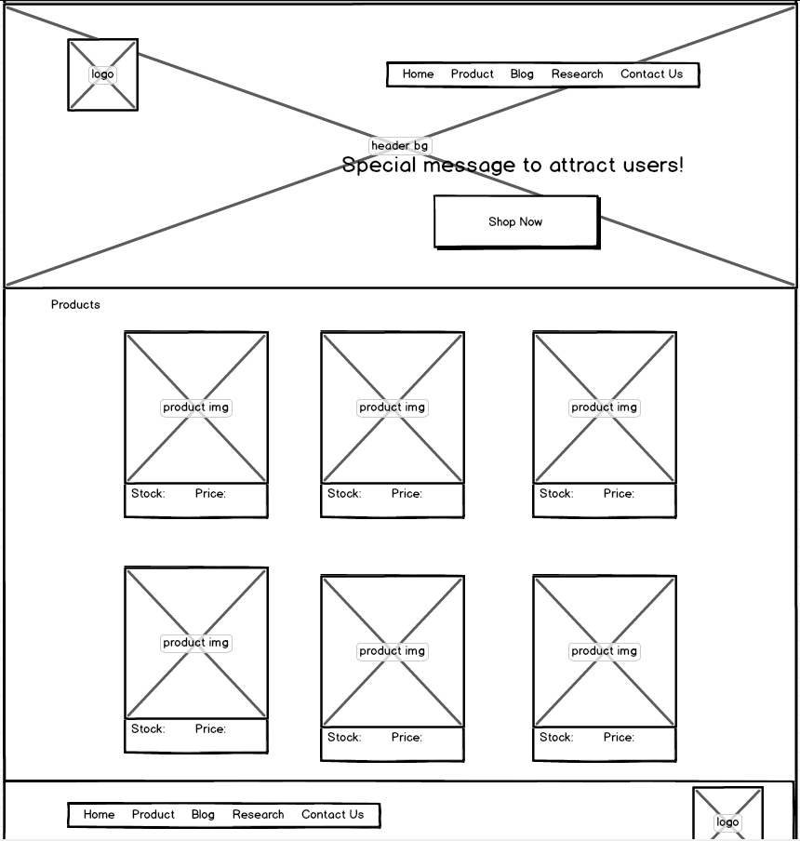

Figure : Wireframe of Product page

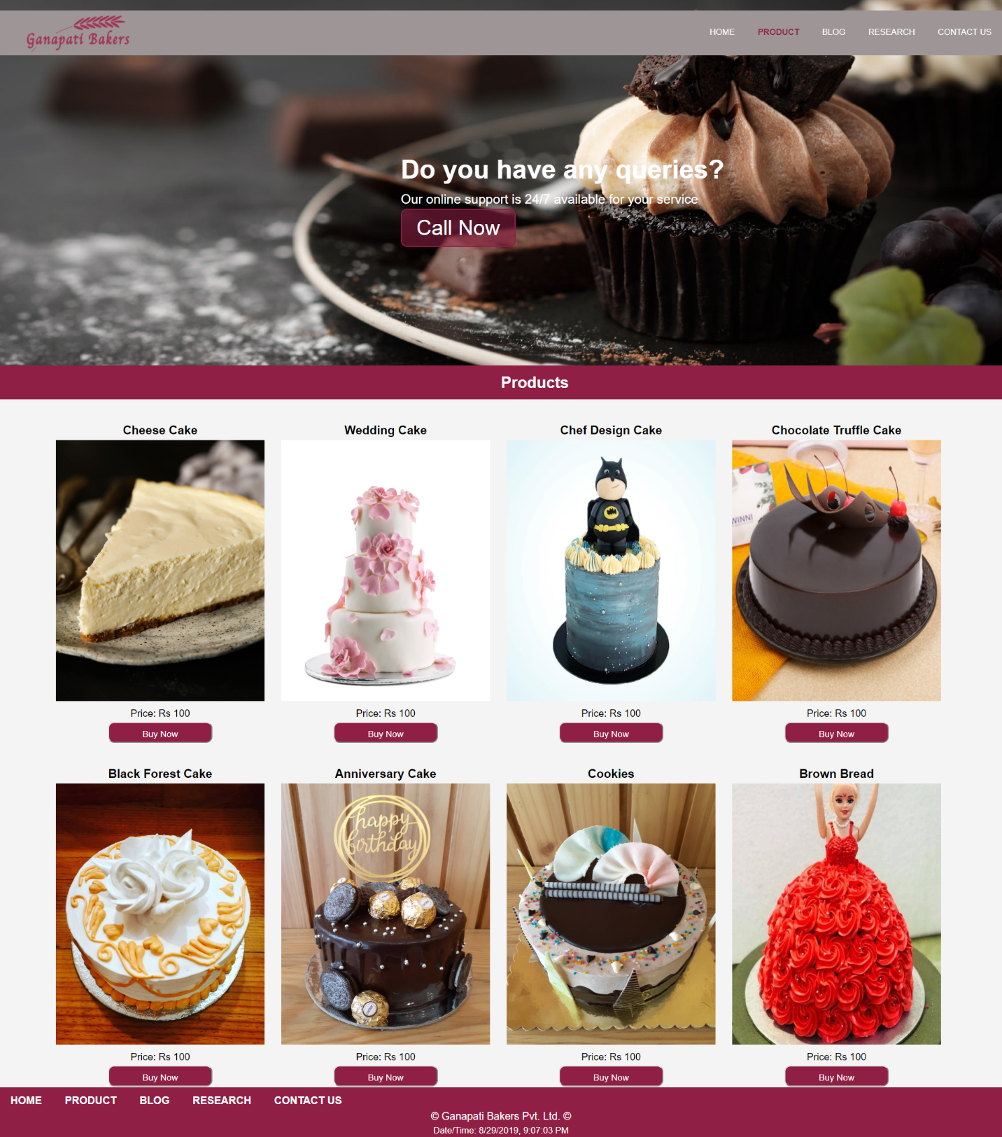

Figure : Design of the Product Page

## Blog

Blog page was created to give the information about the technologies which has influenced the ecommerce and how is this website working and many more information. Blog post were written to give the information of the technology that are changing the style of business and modernizing the business. Wireframe and the website do not match because some of the designs were changed in the development phase.

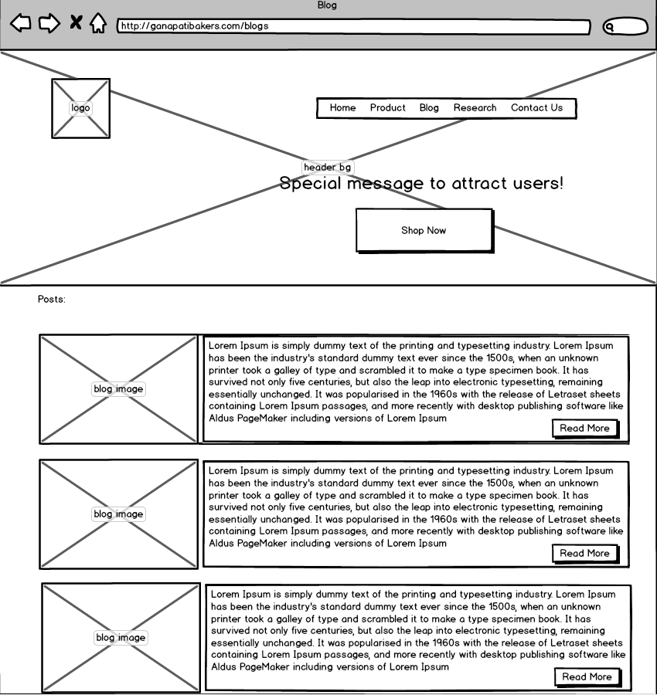

Figure : Wireframe of Blog Page

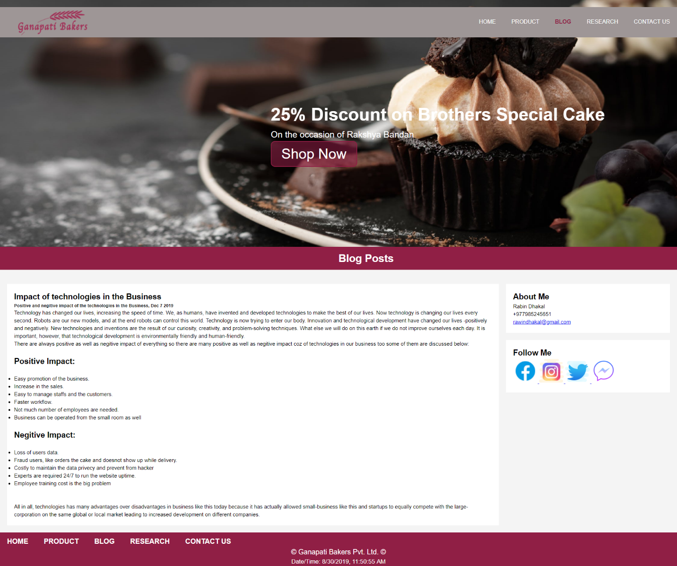

Figure : Design of the blog page

## Research Page

Research page was created to prove that the research was done during the development of the website. Screenshot of the website from where the ideas were taken are display here in the tabular form. Original designs are little different than the wireframes.

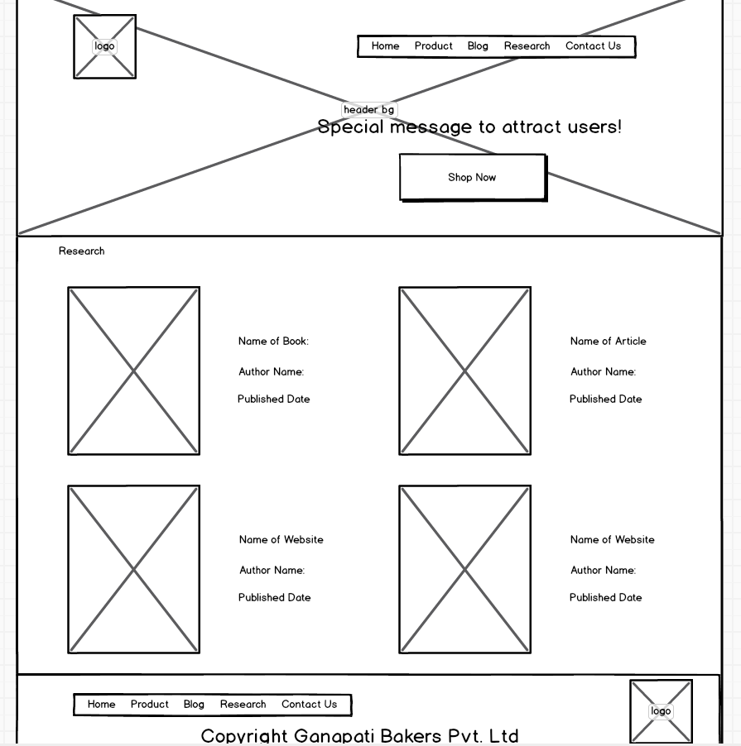

Figure : Wireframe of the Research page

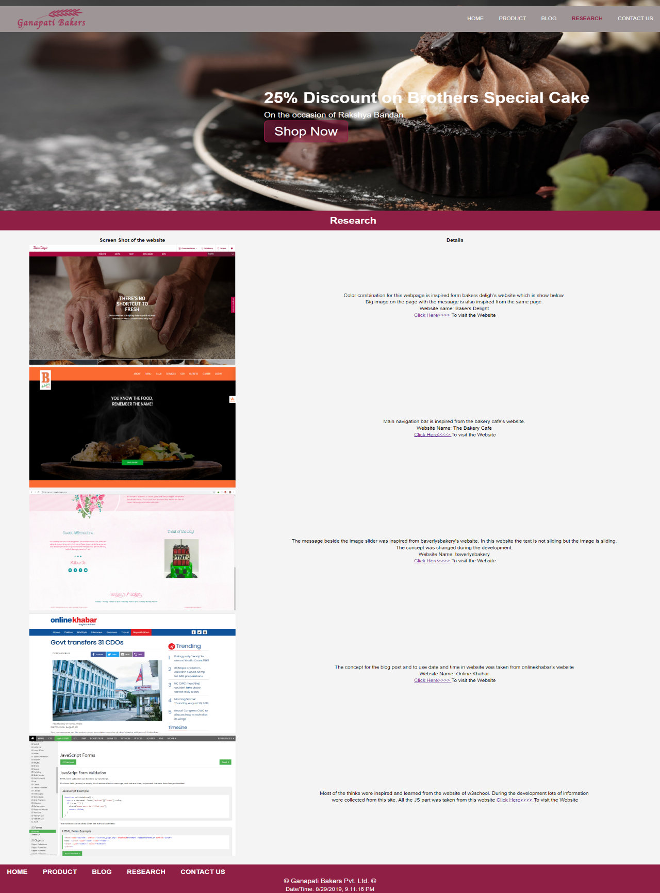

Figure :Design of the Research Page

## Contact Us Page

Contact us page was created to show the detailed location and the contact information of the company through which the user can contact. Embedded google map was used in our page which was copied from google maps. And list of social media icons was given which redirects users to the company’s social media pages. Lastly, contact us form was made, and validation process of the form has been handled by the JavaScript.

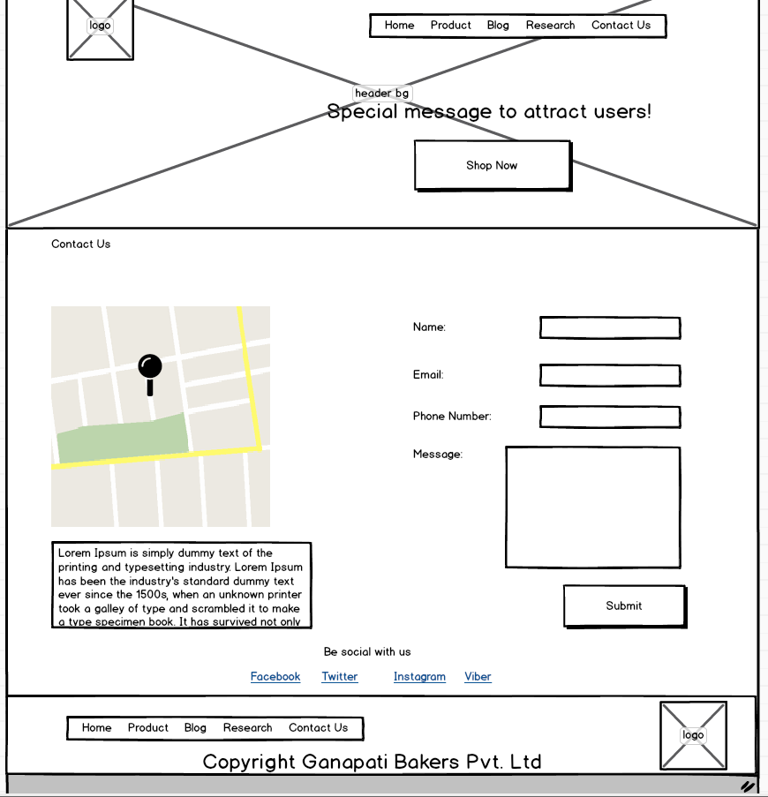

Figure : Wireframe of Contact us page

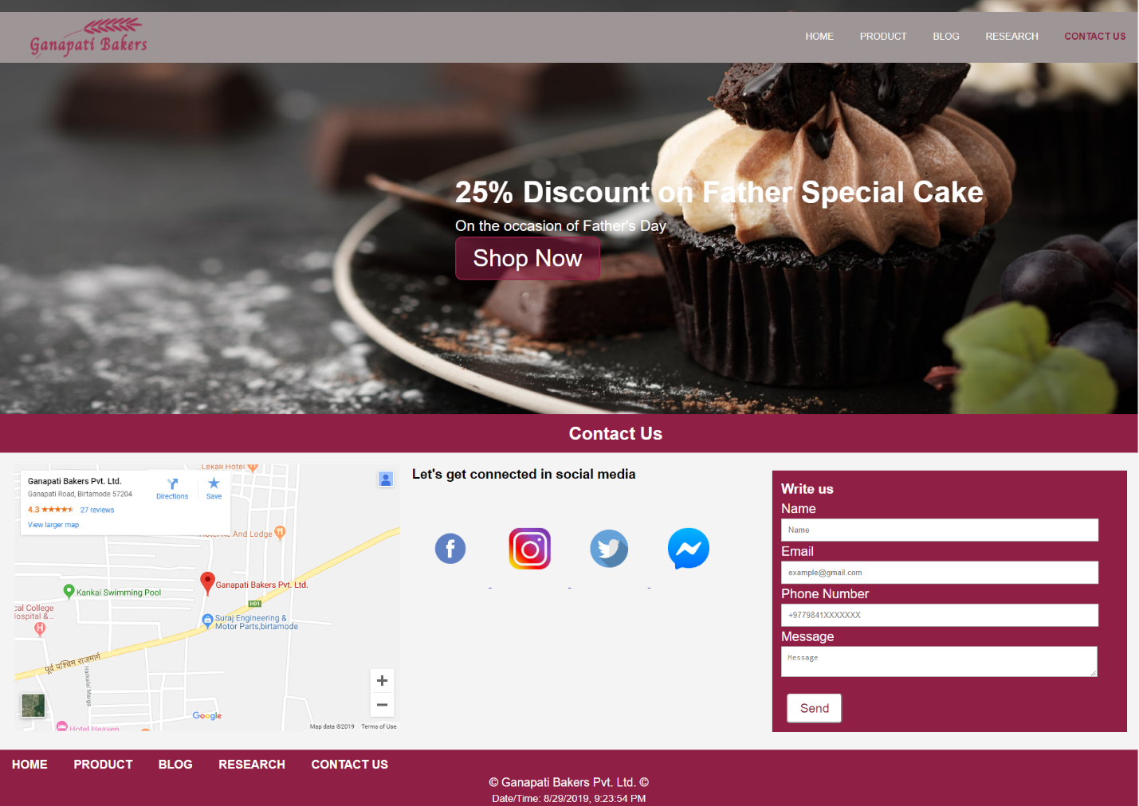

Figure : Design of Contact Us Page

## Product Description Page

Product description page was created to display the detailed information about the product and for ordering the product which has different option to choose from.

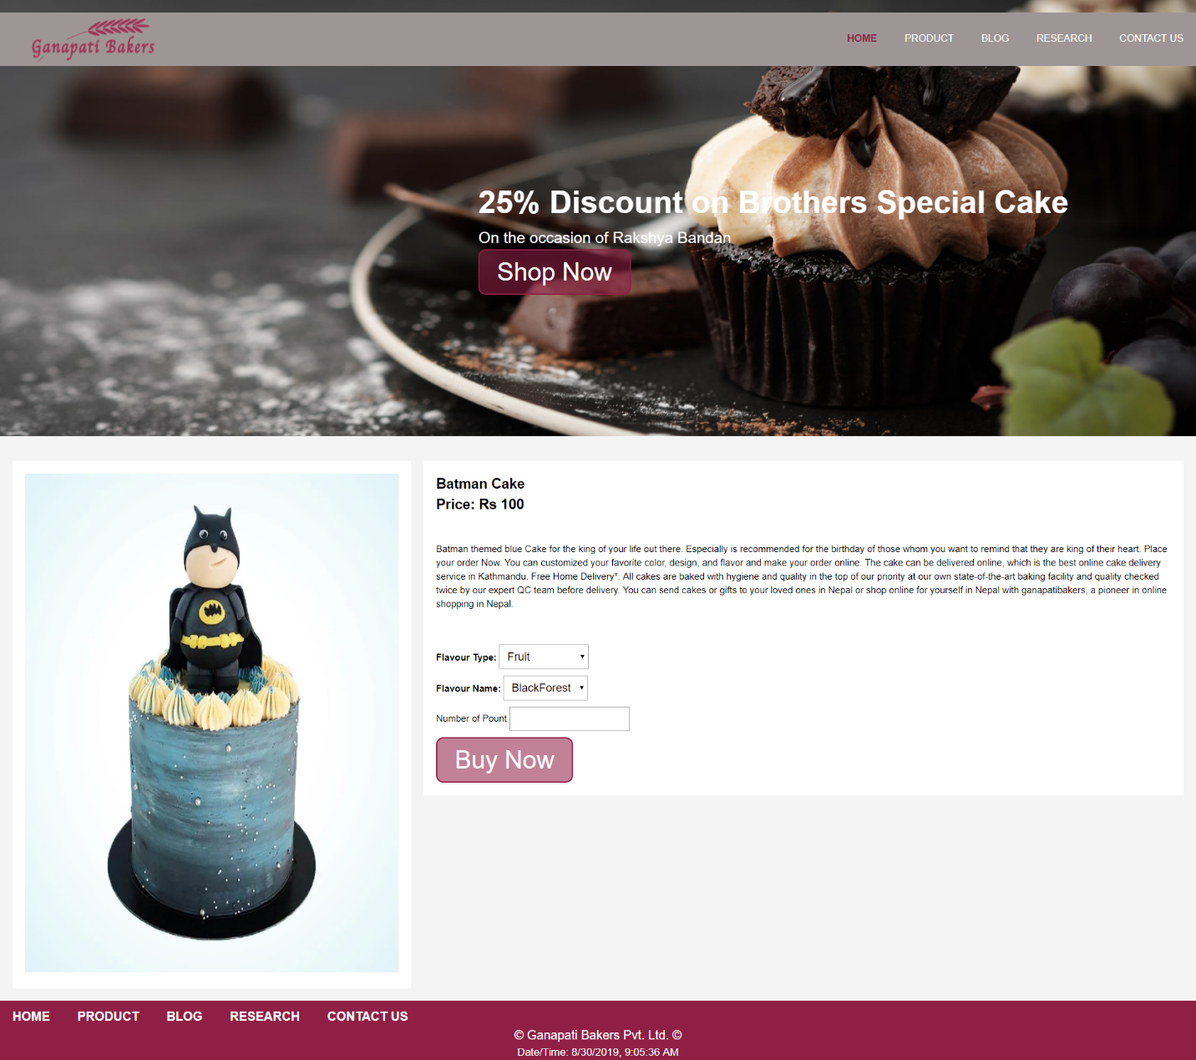

Figure :Design of Product Description Page

# Testing

Testing is another important part of software development. Testing makes sure that program created is bug free. It is essential to test the program after the coding part is completed to know that the written codes don’t have any bugs in it.

For this program black box testing was done to verify that all the JavaScript, CSS animation and hyperlinks are working. Output should be shown corresponding to the given inputs.

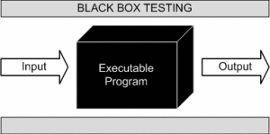

Figure : Black Box testing (softwaretestingfundamentals, 2015)

## Test 1

Hoover animation of the button must change when the courser is placed on the button.

Table : Hoover test

|  |  |
| --- | --- |
| Objective | Checking the hoover effect of the button. |
| Action | * Website was opened * Courser was hovered over the button |
| Expected Result | Translucent button will be filled with the solid color |
| Actual Result | The courser was hovered over the button and the effect was captured |
| Test Status | Passed |

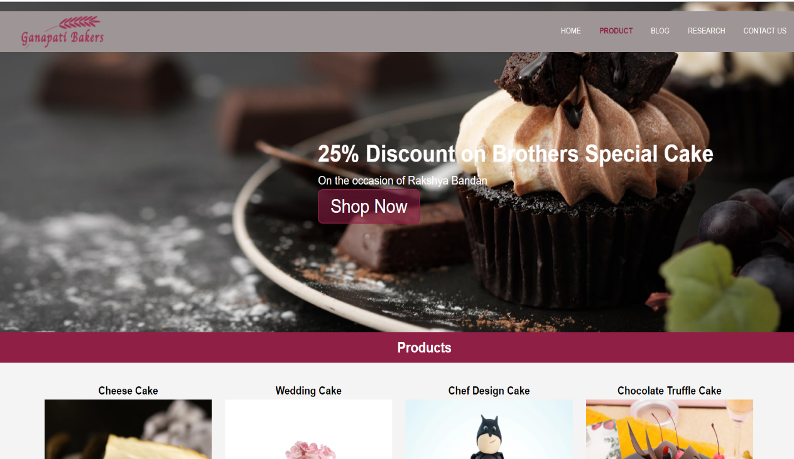

Figure : Before the courser was hovered



Figure : After the courser is hovered

## Test 2

|  |  |
| --- | --- |
| Objective | Checking the functionality of the image slider. |
| Action | * Website was opened * Image slider was evaluated |
| Expected Result | Image must change |
| Actual Result | Image was changed every 3 seconds |
| Test Status | Passed |

Table : Image Slider test

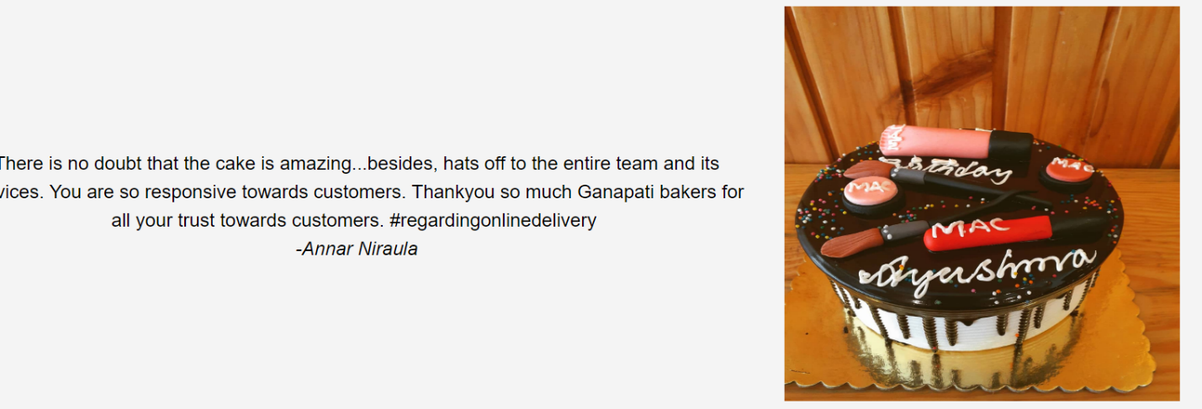

Figure : Image Slider Test 1

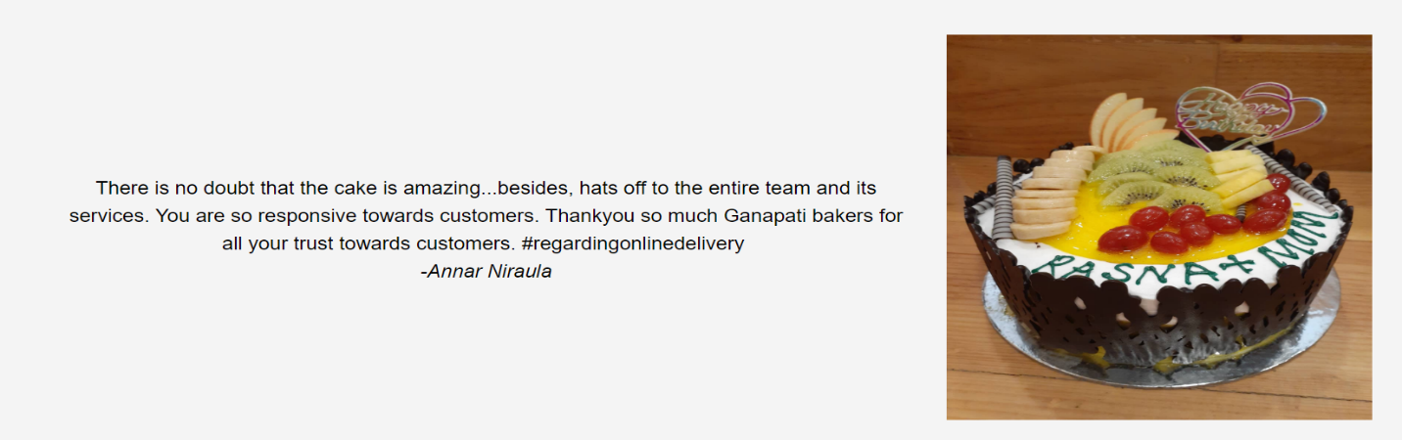

Figure : Image Slider Test 2

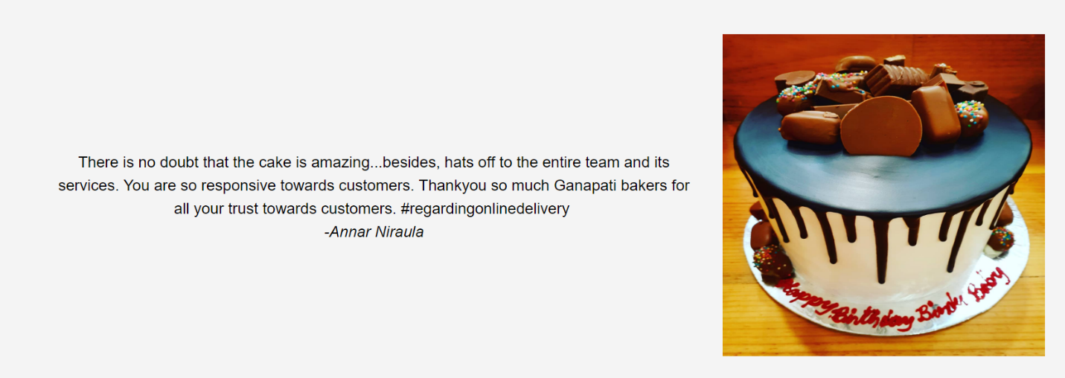

Figure : Image Slider Test 3

## Test 3

Form validation test was done based on the various conditions.

|  |  |
| --- | --- |
| Objective | To get error when the form is submitted when all the fields are empty |
| Action | * Website was opened * Navigated to contact us page * Send button was licked |
| Expected Result | Error must be shown above the button saying “All the fields in the form are mandatory” |
| Actual Result | There was the error message saying all the fields are mandatory |
| Test Status | Passed |

Table : Form Validation Test When all field are empty

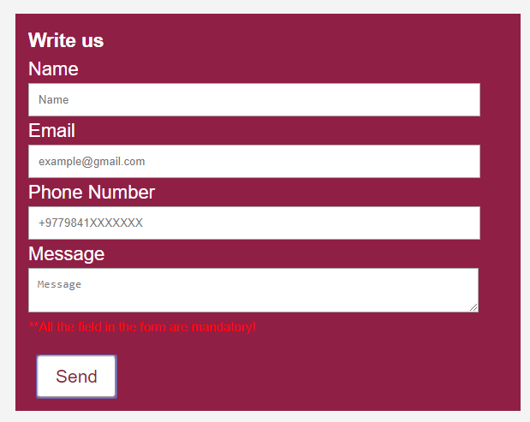

Figure : Form Validation Test When all field are empty

|  |  |
| --- | --- |
| Objective | To get error when the form is submitted without the message |
| Action | * Website was opened * Navigated to contact us page * Name, phone number, email field were filled and send was clicked |
| Expected Result | Error must be shown above the button saying, “Message field is empty.” |
| Actual Result | There was the error message saying Message is empty |
| Test Status | Passed |

Table : Form Validation Test When message field is empty

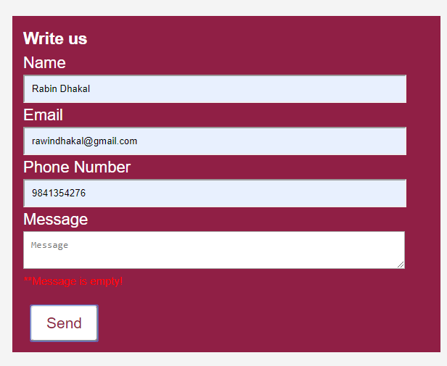

Figure : Form Validation Test When message field is empty

|  |  |
| --- | --- |
| Objective | To get error when the form is submitted without name |
| Action | * Website was opened * Navigated to contact us page * Message, phone number, email field were filled and send was clicked |
| Expected Result | Error must be shown above the button saying, “Name field is empty.” |
| Actual Result | There was the error message saying Name is empty |
| Test Status | Passed |

Table : Form Validation Test When name field is empty

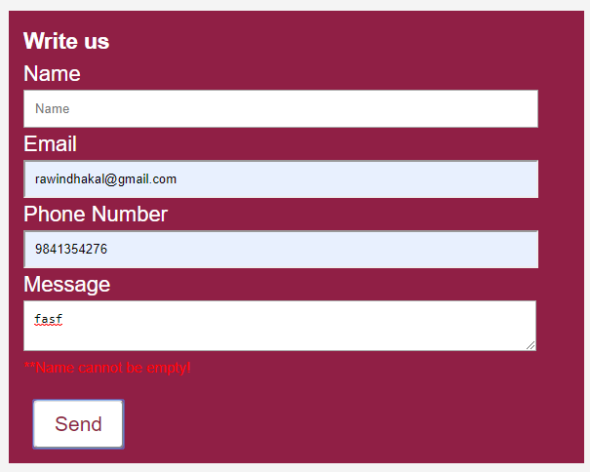

Figure : Form Validation Test When name field is empty

|  |  |
| --- | --- |
| Objective | To get alert message while form is validated |
| Action | * Website was opened * Navigated to contact us page * Message, phone number, email and name field were filled and send was clicked |
| Expected Result | Alert message must be displayed |
| Actual Result | There was the alert message saying Thank you for the feedback |
| Test Status | Passed |

Table : Form validation when all the field are entered

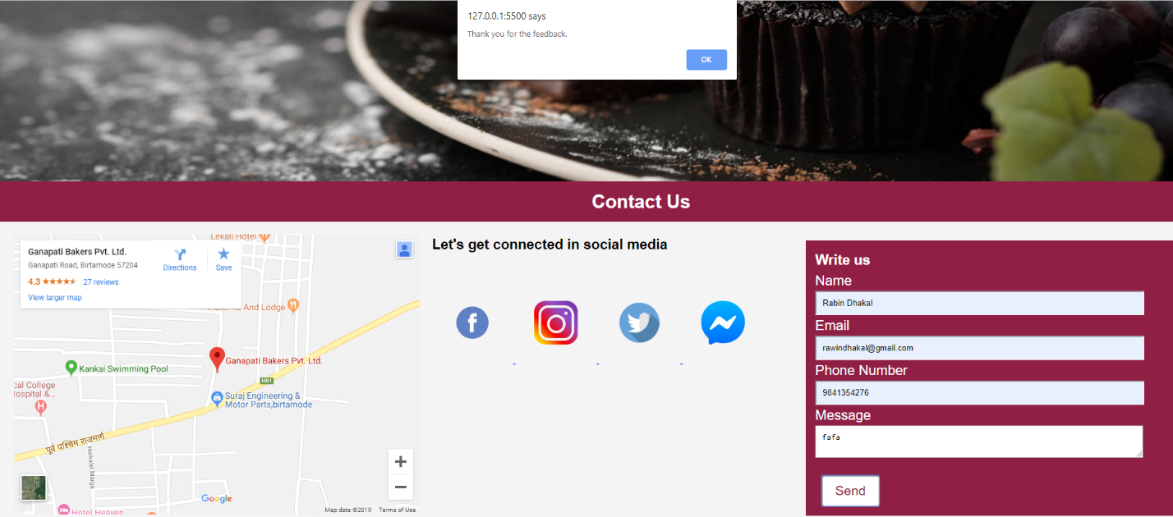

Figure : Form validation when all the field are entered

## Test 4

|  |  |
| --- | --- |
| Objective | To get the same date and time in website and computer taskbar. |
| Action | * Website was opened * Date and time in the computes task bar and website were analyzed |
| Expected Result | Must be same in both the place |
| Actual Result | Date and time were same in both the place |
| Test Status | Passed |

Table : Testing Date and Time

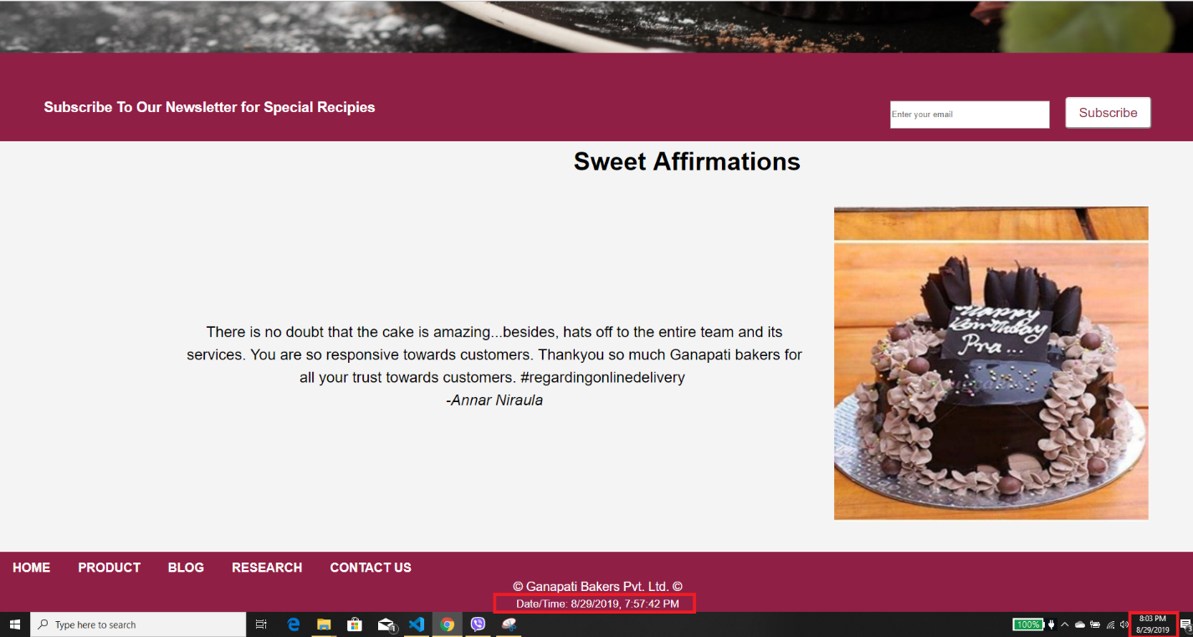

Figure : Testing Date and Time

## Test 5

|  |  |
| --- | --- |
| Objective | To open the external links in a new tab. |
| Action | * Website was opened * Navigated to contact us page * Instagram icon was clicked |
| Expected Result | Instagram page should opened on another tab. |
| Actual Result | Instagram page opened in a new tab. |
| Test Status | Passed |

Table : Testing links

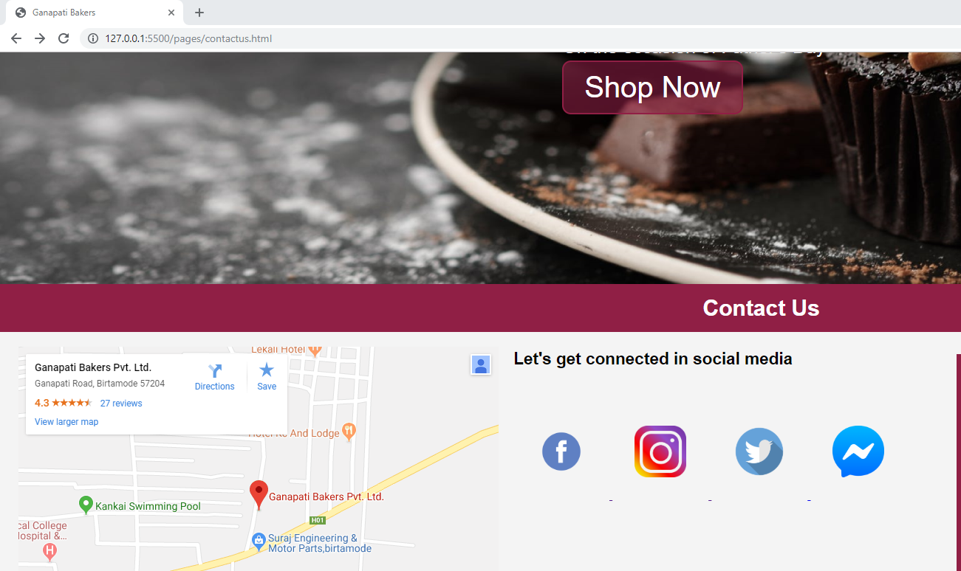

Figure : Testing link Social Media

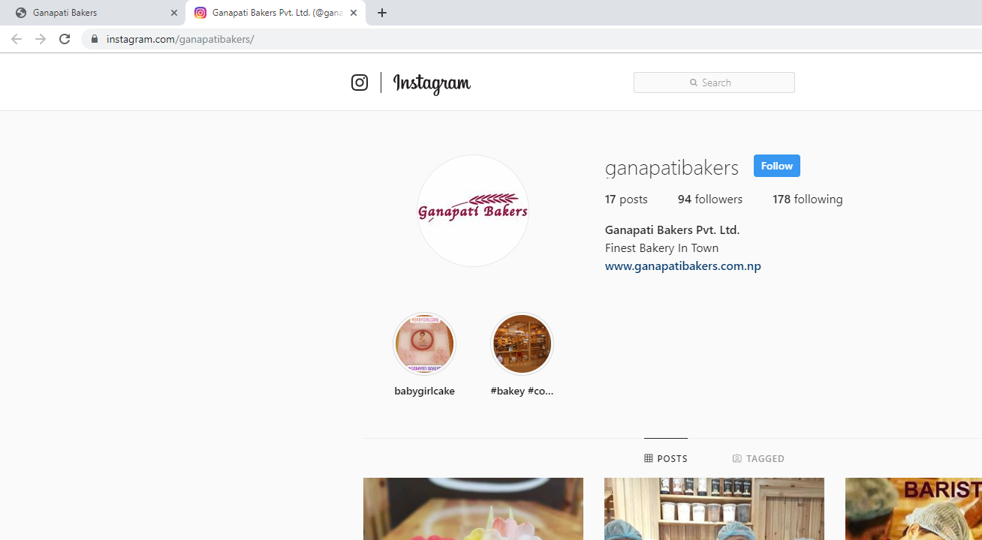

Figure : Loaded Instagram on another page

# Conclusion

This coursework was assigned on 22nd week. After completing this coursework many internet technologies and the impacts that internet has made in the daily lives, design and develop the website with the web technologies like HTML, CSS and JavaScript were understood. Understanding the structure of the website and simple navigating principles was fun.

To complete this coursework, reference of various ecommerce website was taken and constant consultation with the tutor was made regarding the confusions in designs and development as well. Before starting the coursework researched many websites and specially w3school helped a lot during the confusion. Visual Studio Code did a tremendous help throughout the coursework with its features of auto indentation, code completion, live servers and many more.

This coursework helped to learn more about the HTML, CSS and JavaScript. Which will be helpful to become the front end web developer.

# References

HAAS, N., 2011. *orbitmedia.* [Online]   
Available at: https://www.orbitmedia.com/blog/7-reasons-to-wireframe/  
[Accessed 28 August 2019].

Shannon, R., 2018. *HTML Source.* [Online]   
Available at: https://www.yourhtmlsource.com/starthere/whatishtml.html  
[Accessed 29 August 2019].

softwaretestingfundamentals, 2015. *Black Box Testing-softwaretestingfundamentals.* [Online]   
Available at: http://softwaretestingfundamentals.com/black-box-testing/  
[Accessed 02 May 2019].

TutotialsPoint, 2014. *tutorialspoint.* [Online]   
Available at: https://www.tutorialspoint.com/javascript/javascript_overview.htm  
[Accessed 29 August 2019].

W3Schools, 2016. *CSS Introductionq.* [Online]   
Available at: https://www.w3schools.com/css/css_intro.asp  
[Accessed 29 August 2019].